WEST VISAYAS STATE UNIVERSITY
CALINOG CAMPUS
School of Information Communication Technology
Calinog, Iloilo

PROJECT DOCUMENTATIONS
“STAYBOOK HOTEL MANAGEMENT SYSTEM”

A Project Submitted in Partial Fulfillment of the Requirements for
CIT 207 – OBJECT – ORIENTED PROGRAMMING

Submitted By:
Bacarisas, Eui-jin
Jimenez, Jharell
Pastrana, Pinkle Rose
Mongato, Ahlea
Lebuna, Julie-ann
Barnizo, Merry Joy

Section: BSIT 2-B

Submitted to:
Cabigting, Bryan William C.

1st Semester, School Year 2024 – 2025
Project Overview
A. Brief description of the project
Staybook Hotel Management System is a hotel reservation system a software tool used to book rooms through the front desk. It helps staff see room availability, manage reservations, process payments, and store guest information. It makes the booking process faster, more organized and easier for both the hotel and the guests.

B. Target users or organization

- Front Desk Staff
- Hotel Manager
- Accounting or Finance Staff
- Reservation Staff

C. Context of where or how it will be used

The Staybook Hotel Management System will mainly be used in the front desk area of small to medium hotels staff will use it to check guests in and out, see available rooms, handle reservations and record payments. The system is made for hotel employees who may have different levels of computer skills, so it needs to be easy to used, organized, and dependable. Since many small hotels don’t have advanced equipment, the system is designed to work well in places with limited technical resources.

System Overview

A. User Roles

  - Front Desk Staff – The one using the system always. They used it to check if there’s new reservation, update booking information and to check the bills and to pay.
  - Hotel Manager – They monitor daily operations, view reports, track revenue and manage room rate.
  - Accounting or Finance Staff – They used it to track payments generate billing and manage financial records.
  - Reservation Staff – They use the system to manage bookings received through phone calls and walk ins.

B. Main Features

Authentication Module

- User registration and account creation
- Secure login system with username and password validation
- Multi-user support with individual user accounts
- Session management for secure access control

Room Management Module

- Add new room records with complete details
- Edit existing room information
- Delete room records
- View all rooms in a searchable table
- Track rooms status (Available, Occupied, Maintenance)
- Store room specifications including type, price rate, capacity, and description
- Real time search and filter functionality

Reservation Management Module

- Create new guest reservation
- Edit and update existing reservation
- Delete reservation records
- View all reservations in a comprehensive table
- Track guest information (name, contact details)
- Manage check in and check out dates
- Monitor payment status (Paid, Pending, Cancelled)
- Automatic room status updates when reservations are created it modified
- Real time search and filter capabilities

User Interface Features

- Intuitive navigation between Room management and Reservation sections
- Separate database embedded in table rows for quick access to edit and delete functions.
- Dialog based forms for adding and editing records
- Responsive search bars for instant data filtering
- Visual status indicators for rooms and payments

C. Tools and Technologies Used

- Pycharm
- Python
- PyQt6
- Qt Designer
- SQLite
- Python built in SQLite3
- Git
- DB Browser
- Python Package Installer (pip)
- Figma

D. Programming language(s), database, frameworks, and tools

Programming Language
- Python
Data Management System
- SQLite
Framework
- PyQt6
Development Tools
- Pycharm
- Qt Designer
- Pyuic6
- DB Browser
- Python Package Installer (pip)

Design and Implementation

A. System Architecture

In the Staybook Hotel Management System the frontend, backend, and database work together to make the system function smoothly.

The frontend is the part that users see on the screen wherein a staff member clicks a button or enters information, the frontend sends the request to the backend. The backend processes the request it decides what needs to happen for example, checking room availability or saving guest details. If the backend needs to store or get data, it communicates with the database.

The database keeps all the important hotel information, such as reservation guest records, and room status. After getting or saving data, the database sends the information back to the backend, and the backend sends the result to the frontend, which updates what the users see.
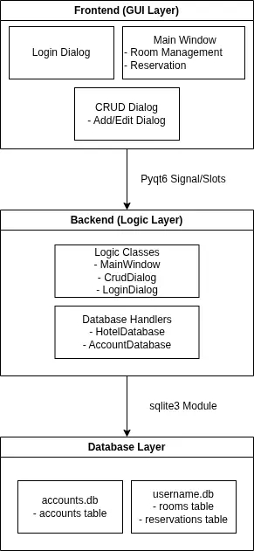

B. Database Overview

Accounts Table (accounts.db)
- Stores log in credentials
- Columns: uid, username, password
- Purpose: User authentication

Rooms Table (username.db)
- Stores hotel room information
- Columns: room_number, type, price_rate, status, capacity, description
- Purpose: Track all available rooms and their details

Reservations Table (username.db)
- Stores guest booking
- Columns: guest_id, guest_name, contact, room_number, checkin_date, checkout_date, payment_status
- Purpose: Track guest reservations

Relationship: Rooms <-> Reservation
- Type: 1 to many (1 Optional to Many Mandatory)
- One room can have many reservations over time
- One reservation must have exactly one room
- Foreign Key: room_number in reservations references room_number in rooms
- Effect: cannot delete a room with active reservations, cannot create reservations for non-existent room

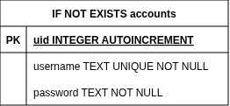

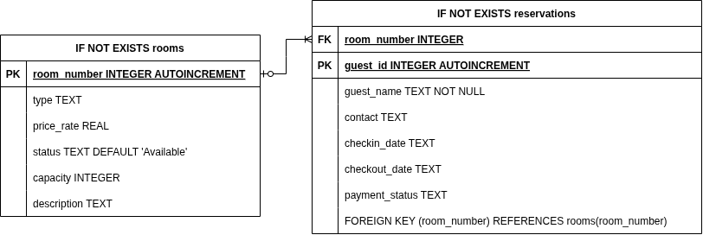

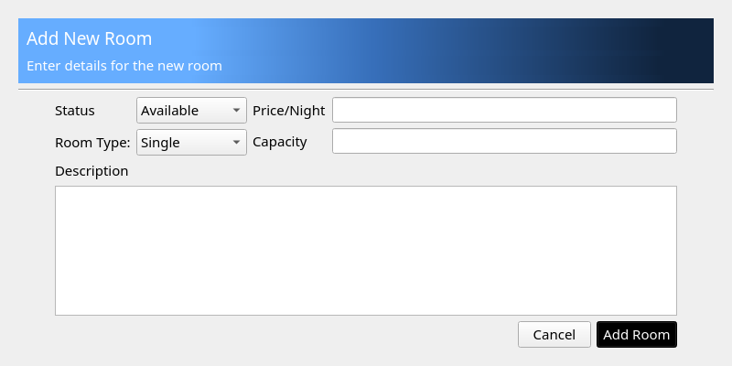
C. User Interface

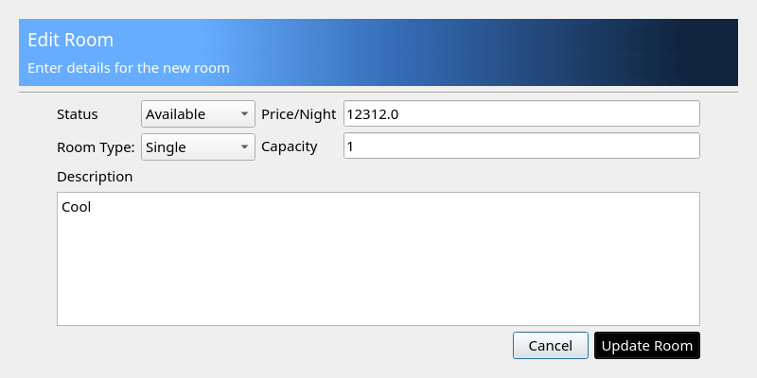
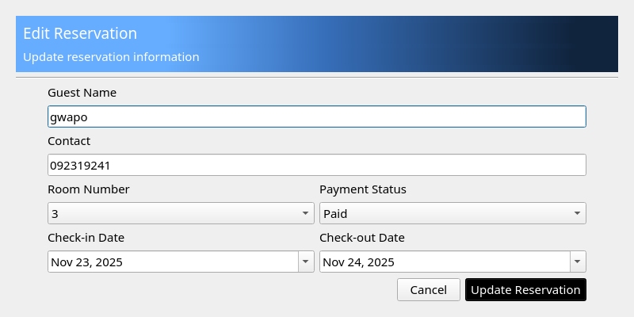
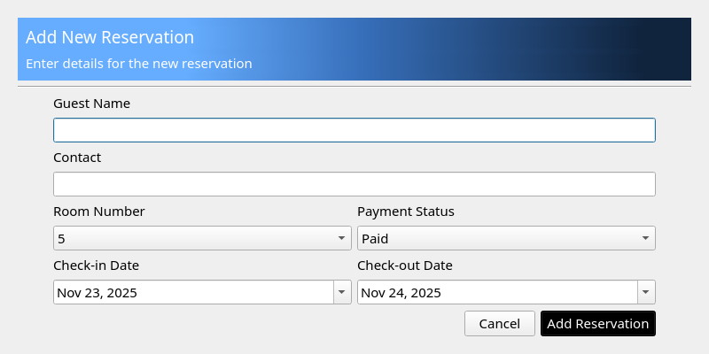
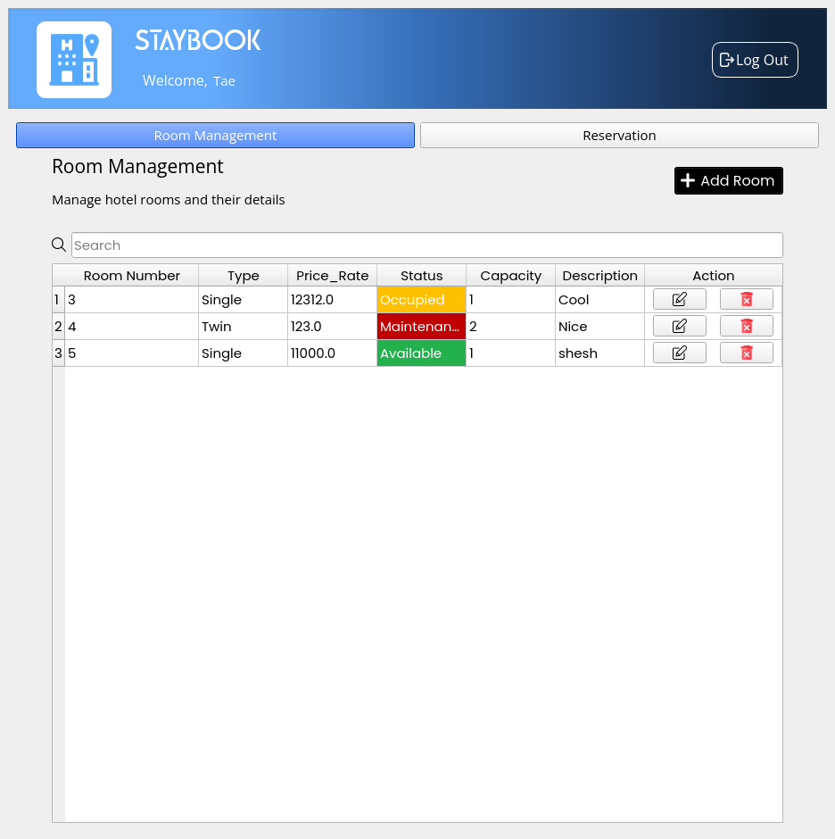
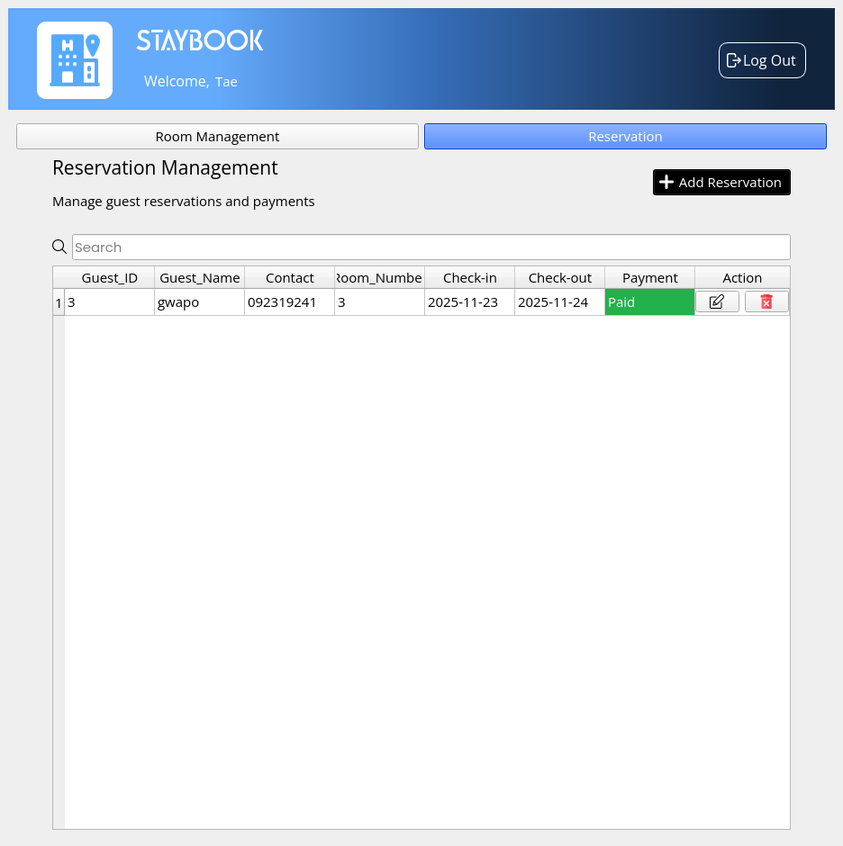

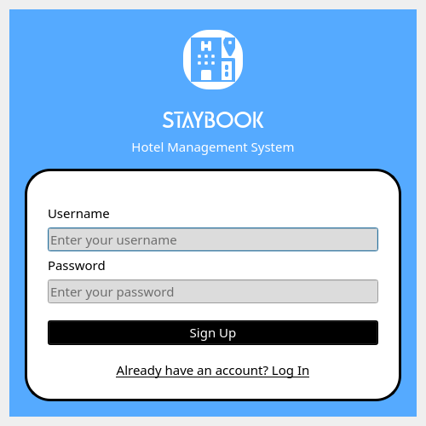
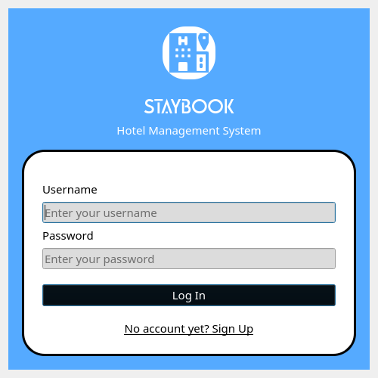

Testing and Evaluation

A. Testing Approach

The system was thoroughly tested to ensure all features worked properly. Login, room management, and reservation functions were checked to confirm that data could be added, edited, updated, and deleted correctly. The interface was tested for responsiveness, real- time updates, and consistent display on different screens. The communication between the fronted, backend, and database was also verified to ensure smooth interaction. Multiple user accounts were tested to make sure each could only access their own data. Various invalid inputs, edge cases, and error scenarios like double bookings and corrupted database files were simulated to see how the system responds. Overall, the tests showed that the system is stable, secure, and reliable under different condition

B. Issues Encountered and Fixes

Issue | Description | Fix
Icons/Logos  Not  Display | Image disappeared after converting .ui to py file with pyui6 because paths broke  During conversation | Moved all image loading backend Python files using Qpixmap() instead of defining  Them in Qt designer
Table Data  Not Showing  On Login | Tables appeared empty when logging back in, even though data existed in database. Data only showed after inserting new record | Added display_rooms() and display_reservations() calls navigation methods ( showRooms(), showReserve()  ) to load data when switching
Room Status  Not Saving | Selected status (e.g., ”Maintenance”) was ignored, rooms always saved with “Available” status | Updated SQL INSERT statement to include status column and passed status value from dropdown to add_room() method
Search  Clearing  Tables | Tying search field cleared tables permanently, filtered result didn’t appear and data didn’t return when clearing search | Implemented two_stage approach: stored all data in self.all_rooms/self .all_reservations, then filtered in-memory data without losing original dataset

Summary and Recommendations
A. Summary (Short recap of the system and its main features.)

Staybook Hotel Management System is a simple and accessible hotel management system design for small to medium sized hotels. It focuses on making daily hotel tasks easier and more organized. The system offers important features like room management, reservation handling, guest information storage, and payments tracking. It’s easy to use interface and reliable local data storage help hotels reduce errors, speed up operations, and provide better service to the guest. It helps hotel manage their work more efficiently without needing complicated or expensive systems.

B. Conclusion (Overall remarks on the system’s performance and usefulness.)

The Staybook Hotel Management System works well for small hotels. It’s easy to learn, simple to use and helps staff organize information, update room status faster, and check guest or reservation details quickly. Even with some limits like fewer users at a time, limited integrations, and no advanced analytics, its stability, practical features and user friendly design make it a useful tool for managing hotel operations and improving guest service.

C. Recommendations (Suggested improvements and future enhancements.)

- Addressing Current Limitations – Resolving issues like limited multi-user access and lack of online booking integration.
- Expanding Capabilities – Increasing the system’s applicability to a broader range of properties.
- Practical Accessibility – Ensuring the software is easy to use and accessible for small and medium sized hospitality establishments, helping them operate efficiently and serve guests effectively.

